Lab-3
ID : AF05054428
NAME : Vignesh S
Batch code : ALP33393
Module : Data Visualization
TASK 3:
Create following table or use dataset
Such as Accessories ( Laptop, Mobile, Tv , Shoes such as ) with dummy data. To find product price with help of product name
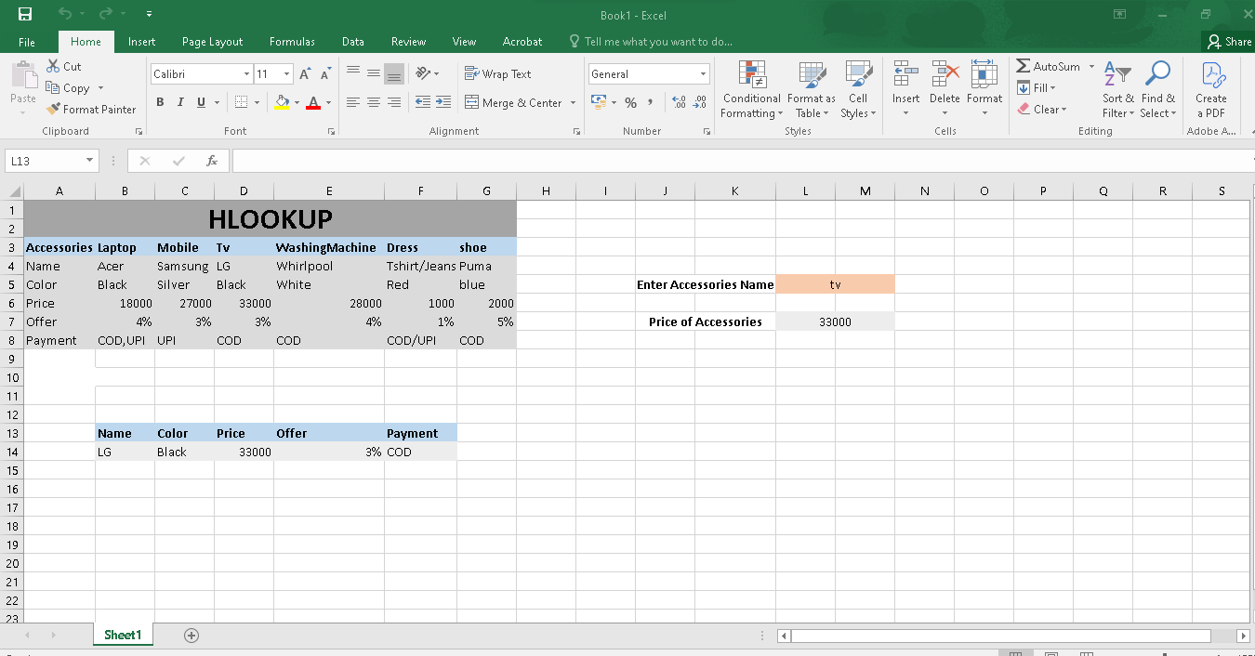
Formula :
1.Hlookup (Single Value)
=HLOOKUP(L5,B3:G8,4,FALSE)
2.Hlookup (Single to Multi)
=HLOOKUP(L5,B3:G8,{2,3,4,5,6},FALSE)
Explanation :
This task about using HLOOKUP in excel to find Accessory details based on Accessory name .In a single to single lookup, Accessory name returns a single value such as price . In a single to multi lookup , , Accessory name returns multiple related details like color, price, offer and payment.

